Assignment 9 (November 9 - 19)

1. Determine the definiteness of the following symmetric matrices:
a) 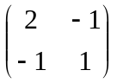 b) 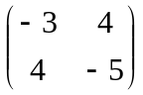 c)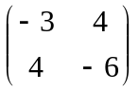 d) 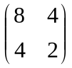
e) 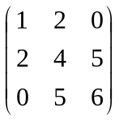 f) 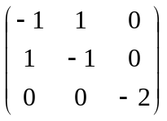 g) 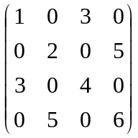
2. Express the quadratic approximation of the function 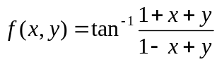 around the point 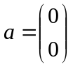.
3. For each of the following functions find the critical points and classify them as local max, local min, saddle point, or "can't tell". What can you say about their global properties (in other words are at least some of them global extrema)?

a. 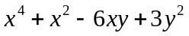,
b. 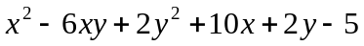,
c. 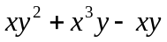.
d. 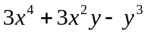,
e. ,
f. 

